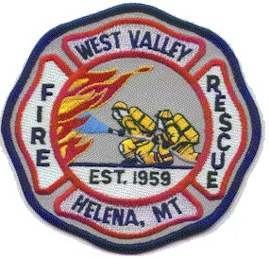

Agenda for May 2025 Trustee Meeting

The West Valley Fire Rescue Board of Trustees will meet on May 8th, 2025 at 7pm in the meeting room of West Valley Fire Rescue Station 1– 1165 Forestvale Rd.

- Opening of the meeting
Roll call
Reading and approval of the minutes of last months meeting
Communications

- Public Comment that is not on the agenda below

- Approval of warrants and financial reports

- Trustee and Officer reports

- New business
Election of Trustee Officers
Approval of FY 2025-2026 Budget
Discussion on tree removal at Witlatch Station
Discuss possible summer staffing
Request money for trees and shrubs for east lawn

- Adjournment

_____________________________________________________________

Notice of the next Trustee Meeting

The West Valley Fire Rescue Board of Trustees
Next scheduled meeting is June 5th, 2025 at 7pm
To be held in the meeting room of Station 1 - 1165 Forestvale RD.

An agenda will be posted 48 hours prior to the meeting

